**How to Connect to AWS Linux Instance from a Windows**

**Machine**

**1.** Launch a new Linux Instance.

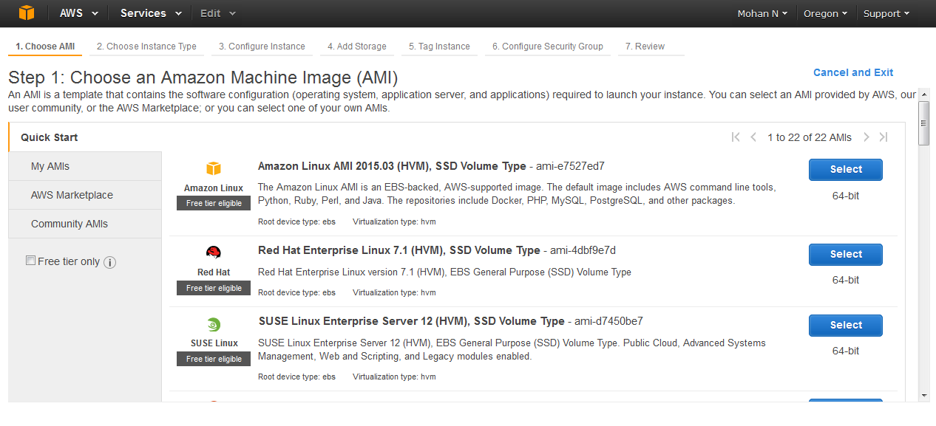

**2.** Ensure that you have opened the SSH port 22 for connecting to Linux.

**3.** Start PuTTy by running **putty.exe**. Enter the public DNS you got in step #4 in the **Host name/IP**

**address** field. Keep the port as 22.

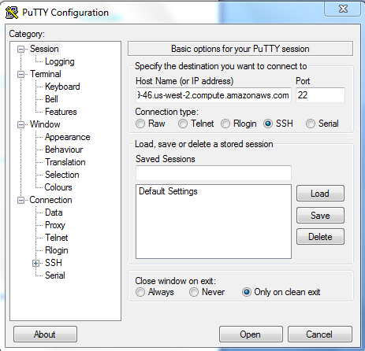

**4.** In the Category tree, select **SSH >Auth** and then provide the key-pair file we used in launching the

instance to connect to the instance.

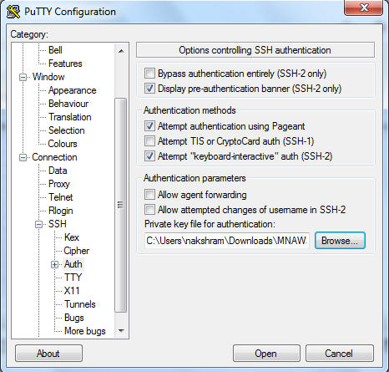

**5.** Click **Open.** The command window (telnet) is launched to connect to the AWS instance.

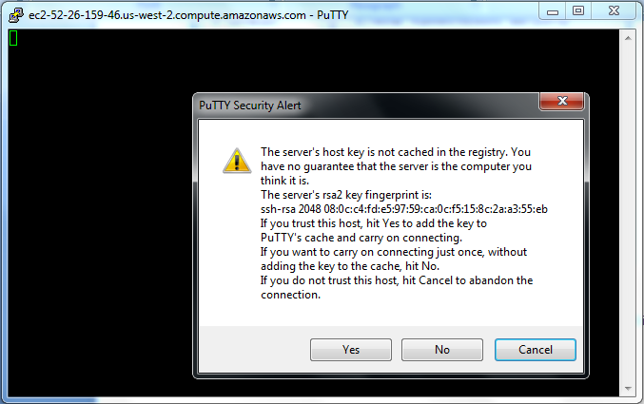

**6.** Click **Yes.** You are prompted to log in.

**7.** For an AWS Linux instance, enter **ec2-user** as the username. (Based on your operating system, the

username might be different.)



If you have given the correct IP address, the Linux prompt is displayed as shown above.

Now you can install and manage your application on the server as required.